CIS SKILL WEEK 2

Enable MFA on the root user of your account and prepare a short note comparing virtual MFA devices, hardware MFA devices and FIDO security keys.

Step 1 :
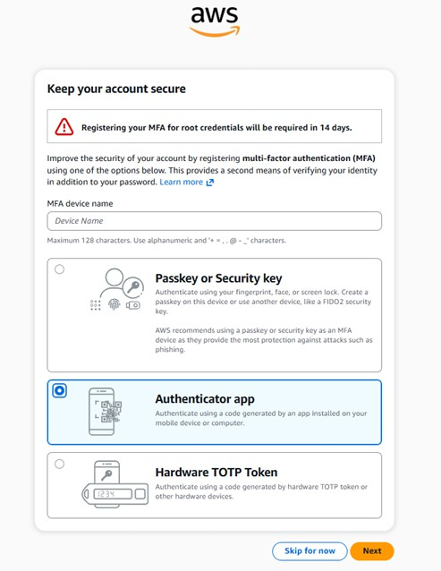

Step 2 :
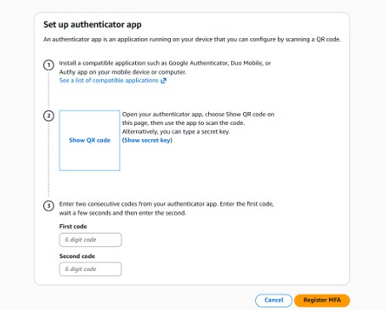

Step 3:
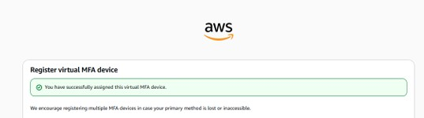

Step 4 :


